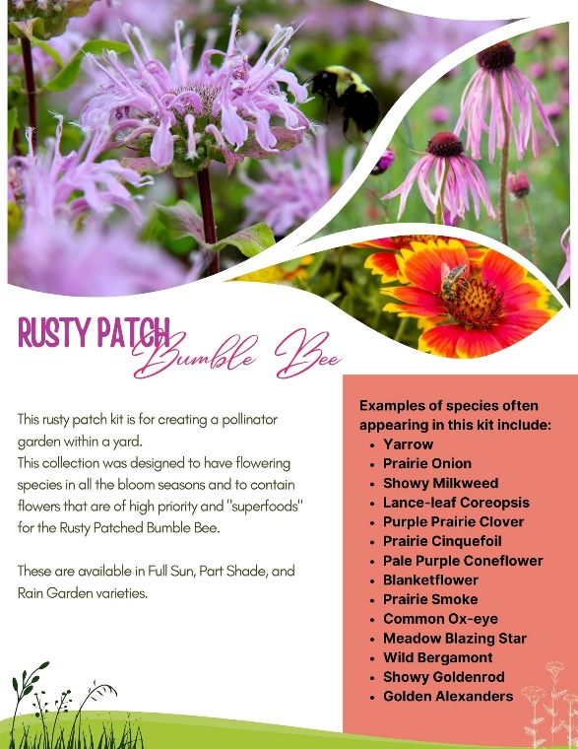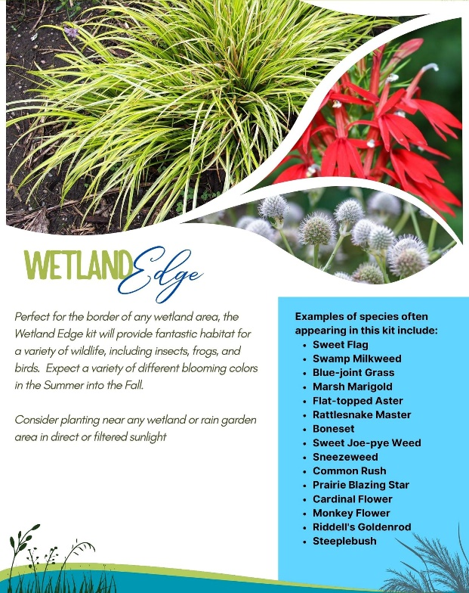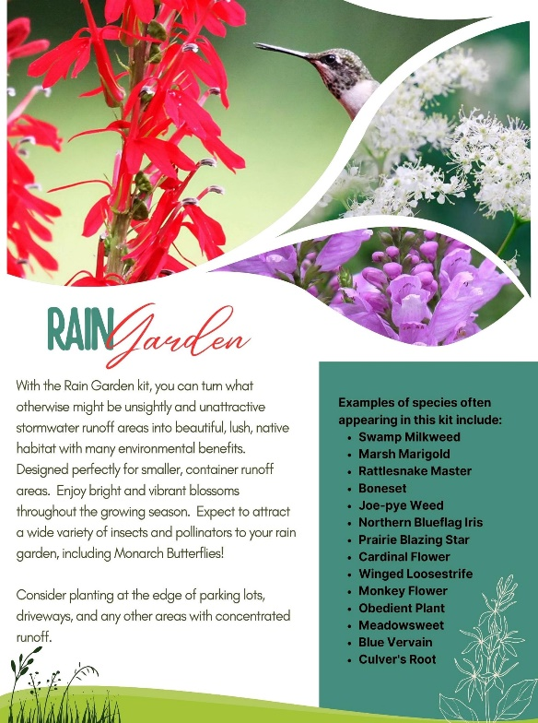

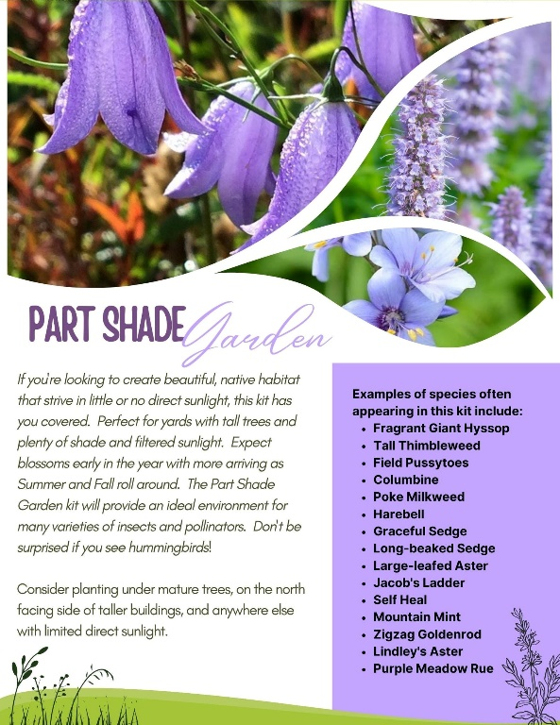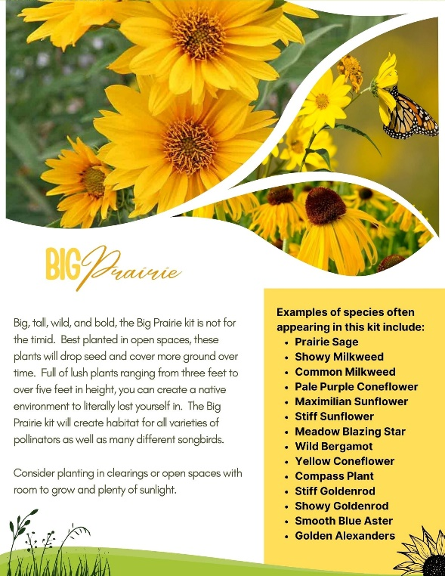

***Designed for a variety of areas and soils, whether it's sandy soil, woodland areas, open areas, shoreline, or wet soil, or if you just want some butterfly and bird attraction, there is a kit to fit your needs.***

***These kits come in trays of 36 plants. Six plants of six different species. Each plant is grown in a large 2 x 2.25 inch wide by 3.25-inch-deep cell. $90.00 for the kit.***

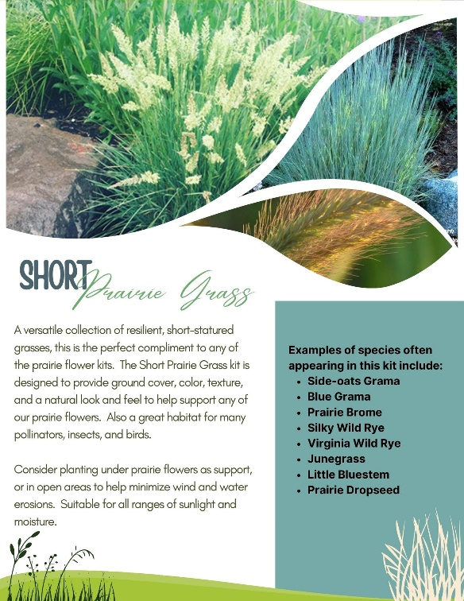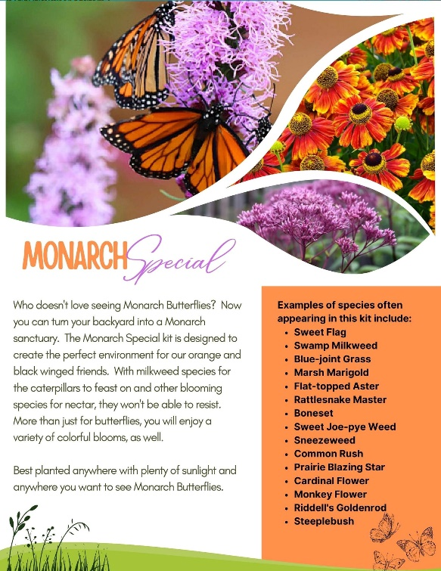***Designed for a***

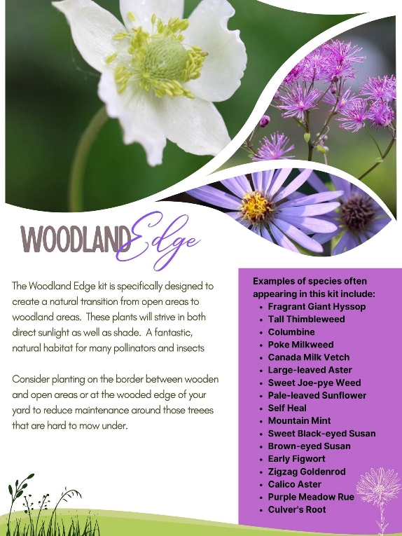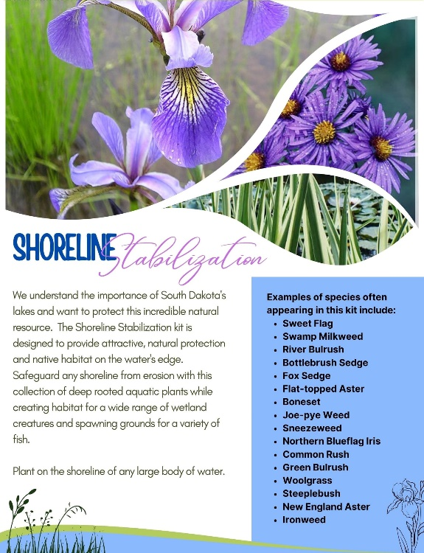

***Designed for a variety of areas and soils, whether it's sandy soil, woodland areas, open areas, shoreline, or wet soil, or if you just want some butterfly and bird attraction, there is a kit to fit your needs.***

***These kits come in trays of 36 plants. Six plants of six different species. Each plant is grown in a large 2 x 2.25 inch wide by 3.25-inch-deep cell. $90.00 for the kit.***